GREEN THUMB

Kristina Woolman

Michelle Trimpin

Juhi Sattar



A WEB APP FOR LAWN SERVICE COMPANIES

Table of Contents

System Requirements 3

Installation 3

User Guide 4

Customer User 4

Project Change Log 11

# System Requirements

● Latest Installment of Java (Java 8.0)

● Windows (7, 8, or 10) or Linux

● Stable Internet connection

# Installation

There is no necessary download or installment needed for using the Green Thumb Lawn Services System (GTLSS). There will be a link provided to access GTLSS once it has been developed.



# User Guide

This guide is intended for users who have already followed the provided link to GTLSS. If you are reading this section but have not navigated to the web-application by clicking the link to GTLSS yet, please refer to the Installation instructions provided in this guide.

## Customer User

As a Customer User of the E-commerce web application, you will be able to access Services and Products, Landscaping Tips, About Us, and Contact pages. You will be able to browse the website, review landscaping tips, read about GTLSS, and contact GTLSS Customer Service. This website will also allow you to select the desired product/service, checkout your final order, and place an order by making an online payment.

**Landscaping Tips Page**

On the Home Page, you can click on the "Landscaping Tips" link, which will redirect you to the basic Landscaping Tips page.

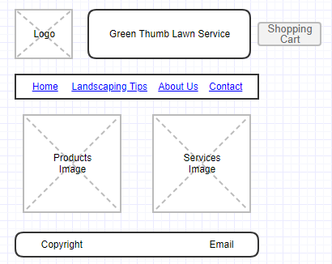

The Landscaping Tips page displays lawn care and services tips (e.g. proper mowing, proper watering, best times for planting, tips for fertilization, tree trimming, etc.)

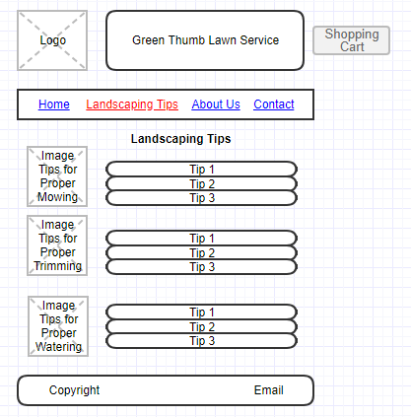

**About Us Page**

On the Home Page, you can click on the "About Us" link, which will redirect you to the About Us page.

The About Us page displays information about the E-commerce lawn services company (GTLSS), including a Company Bio, Honored employees, and Community Service.

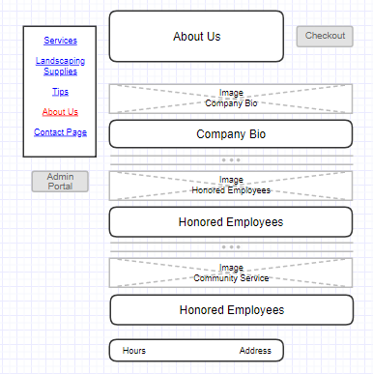

**Contact Us Page**

On the Home Page, you can click on the "Contact" link, which will redirect you to the Contact Us page.

The Contact Us page provides the option to write a comment or question and then email that to the Customer Support team of the E-commerce lawn service company. You will have to provide your name, phone number, and email address into the appropriate fields. Once you finish writing your comment or question, click Send Email button.

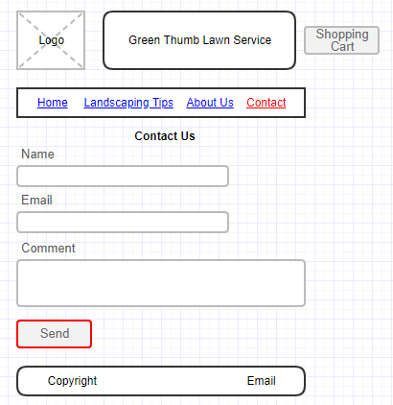

**Services and Products Page**

On the Home Page, you can click on the "Services" or "Products" link/image, which will redirect you to the Services and Products page.

The Services and Products page allows you to select the desired landscaping product or service. Next to each product/service, you will see the "Add to Cart" button. Clicking on this button will result in placing the selected product/supply order into the shopping cart.

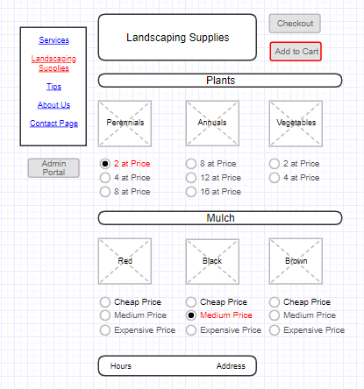

**Checkout**

Once you are done with browsing the website and making your selections, you can click the "Shopping Cart" link available on all pages. This will redirect you to the Shopping Cart page, where you will be presented with an itemized list of Services and Products requested.

Check out steps:

* After reviewing your order, click on the "Submit" button.

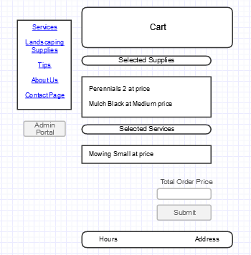

* The billing information form will come up. Fill out the billing information form by providing your name, email, address, credit cart type, number and expiration date, etc.

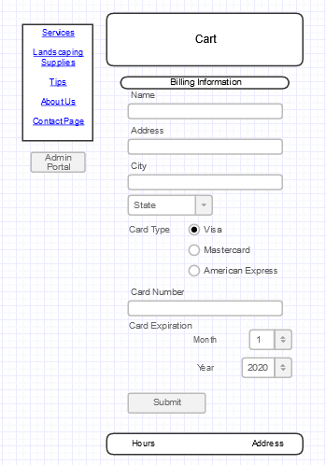

* When you are done with filling out your billing information, click on the "Submit Order" button.
* Once your payment information is verified, you will receive the order confirmation.

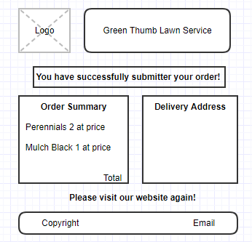

# Project Change Log

|  |  |  |  |  |
| --- | --- | --- | --- | --- |
| Project Change Log for GTLSS | | | | |
| ID | Change Description | Document Changed | Date Revision | Comments |
| 001-U | Removal of Admin User section | User Guide | 4/25/2019 | Removed the entire Admin User (management of the business-related database) section on pages 4-13. |
| 002-U | Change of number of Site Pages | User Guide | 4/25/2019 | Consolidated Services and Landscaping supplies pages into one new Services and Products page on all mockups (pages 4-11). |
| 003-U | Removal of site page Landscaping supplies page | User Guide | 4/25/2019 | Changed any references to Landscaping supplies page to Service and Products page in the use cases (pages 4 and 8). |
| 004-U | Removal of the use case | User Guide | 4/25/2019 | Removed the use case for Services Page (on page 9), have the Services page merged with the Products page creating a use case for Service and Products page. |
| 005-U | Added Cart and Confirmation pages | User Guide | 4/25/2019 | Split the checkout process use case in stages by adding Cart and Confirmation pages on the mockups. |
| 006-U | Removal of Calendar Scheduling | User Guide | 4/25/2019 | Removed the calendar (scheduling of services) from the checkout process use case. Appropriate adjustments were made to the description of the checkout process and corresponding mockups (pages 10-11). |

The source code can be found at: https://github.com/green-thumbs.

Thank you for using Green Thumb Lawn Service System!

